Project title | Roof Solar PV Installation for Residential Buildings in Vulnerable Communities
Sector | Renewable energy, energy efficiency
Location | Vulnerable residential communities in Jiu Valley, Hunedoara County, Romania
Project purpose | To reduce energy poverty and promote the use of renewable energy in vulnerable communities by installing roof solar PV on residential buildings. The project aims to decrease electricity costs, improve living standards, and contribute to Romania’s energy transition goals.
Beneficiaries of the project | • Low-income households in Jiu Valley.  • Local installers and renewable energy service providers.  • The broader community benefits from reduced air pollution and GHG emissions.
Project relevance and need | Jiu Valley, a former coal mining region, faces significant socio-economic challenges, including high levels of energy poverty. Many residents rely on expensive, inefficient energy sources for electricity and heating. Installing solar PV on residential buildings will directly address energy poverty by providing a clean, affordable, and sustainable energy source. This project aligns with Romania’s goals for energy transition, reducing carbon emissions, and increasing the share of renewable energy in the energy mix.
Implementing actor | Local authority
Activities | 1. Community Engagement:  •Engage with residents and local authorities to select suitable buildings for solar PV installation.  •Raise awareness about the benefits of renewable energy and how the project will reduce energy costs.  2. Feasibility Study and Basic-Detail Design:  •Conduct a feasibility study to assess the solar energy potential of selected buildings.  •Develop basic and detailed designs for roof solar PV installation.  3. Procurement and Installation:  •Prepare bid documents and roll-out the tender for the supply and installation of roof solar PV.  •Hire local contractors to install roof solar PV.  4. Operation, Monitoring and Maintenance:  •Implement a monitoring system to track electricity generation and savings.  •Provide training for local technicians to maintain the solar installations.  5. Integration with Energy Communities:  •Promote the formation of local energy communities where residents can share excess energy produced by the solar PVs.  •Facilitate access to funding for future expansion of renewable energy projects in the area.
Expected result(s) | • Energy savings: Estimated annual savings of 30-40% on electricity bills for participating households.  • Renewable energy production: Estimated annual production of 500 MWh.  • GHG emission savings: Estimated reduction of 400 tCO2 eq./y.  • Improved living standards: Reduced energy poverty and improved thermal comfort for residents of vulnerable communities.
Expected contribution(s) and impact(s) | • Significant reduction in electricity costs for low-income households.  • Increased awareness and adoption of renewable energy in the region.  • Job creation through the engagement of local contractors and technicians for installation and maintenance.
Institutional framework | • The project will be led by local authorities in Jiu Valley, with support from regional development agencies.  • Partnerships will be established with renewable energy companies, NGOs, and local businesses.
Budget | Total investment costs: 500,000 EUR  • Solar panel procurement and installation: 350,000 EUR  • Feasibility studies and technical designs: 50,000 EUR  • Smart metering systems: 50,000 EUR  • Public awareness and training programs: 50,000 EUR
Sources of funding or financing | • Just Transition Fund  • EU Cohesion Policy funds  • Climate Fund  • Contributions from local and regional authorities
Implementation schedule | • Feasibility and technical studies: March 2025 - June 2025  • Procurement and installation: July 2025 - December 2025  • Project completion: January 2026
Sustainability | • After installation, the solar PVs will generate free electricity for residents, ensuring long-term energy savings.  • Local technicians will be trained to maintain the system, ensuring the project’s technical sustainability.  • The project will promote the formation of energy communities, allowing households to share excess energy and benefit from collective energy savings.
Replication | This project model can be replicated in other vulnerable communities in Jiu Valley and across Romania, particularly in areas affected by energy poverty and transitioning out of coal-based industries.

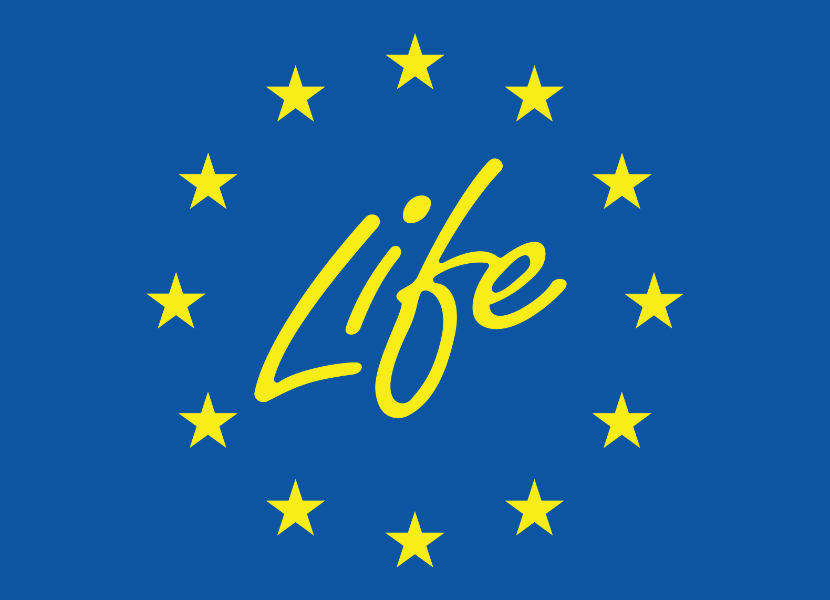
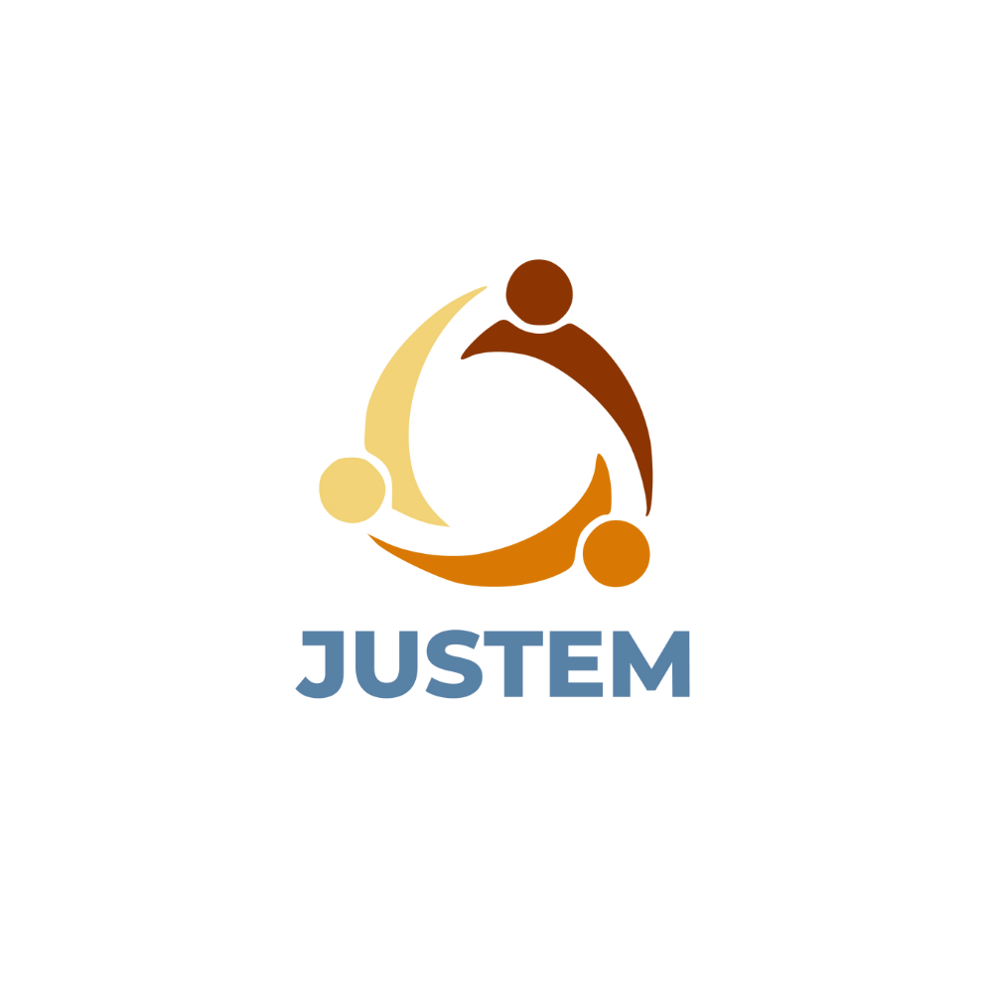
September, 2024
Date of release
Loriana Farkas, AISVJ
Sabina Irimie, AISVJ
Adrian-Lucian Pal, AISVJ
Authors
ABOUT
Co-funded by the European Union. Views and opinions expressed are however those of the author(s) only and do not necessarily reflect those of the European Union or CINEA. Neither the European Union nor the granting authority can be held responsible for them.

